Nathania Kezia

2001586331

Computer Science 2020

For my final project, I thought of making a reservation system. Basically it is a program to reserve something. I’m still deciding whether I want it to be a seat reservation or album reservation but both are pretty much the same. This is pretty much what I thought of. I hope it will work out

This is the chart for seat reservation

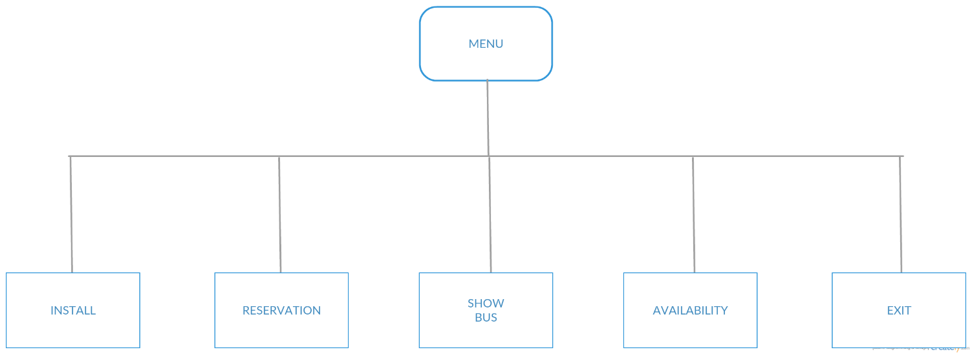

SHOW

INSERT

**Explanation**

1. Menu: The menu will be consisted of 5 options and in the menu, the user will choose what they

want to do

1. Insert: In this option, the user will input the bus information (Bus number, driver, arrival &

departure time, destination) or the album information (Artist, album name, quantity)

1. Reservation: This option is used to reserve the seat that a user wants to reserve
2. Show bus: This option is to show the bus/album information
3. Availability: This option is to show the bus/album availability
4. Exit: This option is to finish/exit the program

P.S Sorry that I didn’t push the file. I tried it a few times but it still didn’t work so I had to upload it.